**SOMAIYA** 

**V I D Y A V I H A R**

**K J Somaiya Institute of Technology**

**An Autonomous Institute Permanently Affiliated to the University of Mumbai**

**DEPARTMENT OF INFORMATION TECHNOLOGY**

**Course: Data Mining & Business Intelligence Lab (ITL601)**

**B.Tech. (Information Technology) – Semester VI**

**Academic Year: 2023-24 (Even Semester)**

**PRACTICAL 4B**

**Aim:**

**Lab Objective:**

**Theory:**

**<Code with Output>:**

import numpy as np

import pandas as pd

np.random.seed(10)

product_type = np.random.choice(a= ["iPhone","iPad","iPod","AVP","AirPods"], p = [0.05, 0.15 ,0.25, 0.05, 0.5],

size=1000)

month = np.random.choice(a= ["January","February","March"], p = [0.4, 0.2, 0.4],

size=1000)

product = pd.DataFrame({"types":product_type,

"months":month})

product_tab = pd.crosstab(product.types, product.months, margins = True) product_tab.columns = ["January","February","March","row_totals"] product_tab.index = ["iPhone","iPad","iPod","AVP","AirPods","col_totals"]

observed = product_tab.iloc[0:5,0:3]

print(product_tab)

Page **1** of **3**

**SOMAIYA** 

**V I D Y A V I H A R**

**K J Somaiya Institute of Technology**

**An Autonomous Institute Permanently Affiliated to the University of Mumbai**

expected = np.outer(product_tab["row_totals"][0:5],

product_tab.loc["col_totals"][0:3]) / 1000

expected = pd.DataFrame(expected)

expected.columns = ["Janurary","Feburary","March"]

expected.index = ["iPhone","iPad","iPod","AVP","AirPods"]

print(expected)

chi_squared_stat = (((observed-expected)**2)/expected).sum().sum() print(chi_squared_stat)

critical_value= 15.50731

print("Critical value:",critical_value)

if (chi_squared_stat < critical_value):

print("Values are corelated ")

else:

print("Values are not corelated")

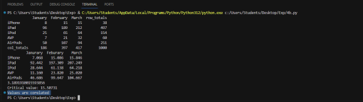

**Conclusion:**

**Lab Outcome:** Ability to identify sources of data for mining and design a Data Warehouse schema. Page **2** of **3**

**SOMAIYA** 

**V I D Y A V I H A R**

**K J Somaiya Institute of Technology**

**An Autonomous Institute Permanently Affiliated to the University of Mumbai**

**Submitted Details -**

**Name of Student: Parth Malviya**

**Roll No.: 22**

**Date of Performance: 7 Feb 2024**

Page **3** of **3**